
Republic of the Philippines
DEPARTMENT OF ENVIRONMENT AND NATURAL RESOURCES
Region VIII, Eastern Visayas
Sto. Niño Extension, Tacloban City

MEMORANDUM

FOR : Secretary Jose “Lito” Atienza, Jr.
DENR, Visayas Avenue
Diliman, Quezon City

Usec Diony A. Ventura
Administrator
National Mapping and Resource Information Authority
Lawton Avenue, Fort Andres Bonifacio, Makati City

FROM : The Regional Executive Director
DENR, Region 8, Tacloban City

SUBJECT : Accomplishment Report of DENR-8 on Implementation of IEC for PRS 92
Program

DATE : August 16, 2007

We are respectfully submitting herewith our accomplishment report for our IEC Component of PRS 92 implementation in Region 8, for the month of July.

Please be informed that the MOAs entered with the three municipalities are still to be signed by the Mayors. The PRS IEC Team established open communication links with these municipalities for the retrieval of the MOAs as soon as these are acted by the Mayors.

Also, the SB council requested for ample time in enacting the municipal ordinance under the “Adopt-a-Mojon Program because said ordinances have still to pass through series of readings.

There was also a clamor from the DENR personnel especially those involved in land management and disposition to be oriented about the PRS ’92 Program.

For information and further instructions.

ALFREDO S. PASCUAL, CESO III

ACCOMPLISHMENT REPORT ON THE IEC FOR PRS 92 IMPLEMENTATION
DENR, Region 8, Tacloban City

One of the components of the PRS 92 implementation is the Information Education and Communication (IEC) Activities which consists of several tri media strategies. Per approved Work and Financial Plan for IEC, Focused Group Discussion among local government units was targeted starting the month of July among other IEC activities in the succeeding months of 2007. The Regional Public Affairs Office (RPAO) and the Field Network Survey Party, started the implementation of the said Work and Financial Plan in three municipalities of Panaon Island in Southern Leyte for the month of July. These were conducted in the municipalities of San Francisco, San Ricardo and Pintuyan, all in Southern Leyte.

Objectives of the IEC are: To orient the local officials in target municipalities about the importance of PRS 92 program; to inform them of their roles and responsibilities so that they can help the DENR in the implementation of the PRS 92 program in their respective municipalities; and ultimately to enlist the participation of municipal/barangay officials/residents for the adoption of identified Geodetic Control Points (GCPs) or “mojons”, so that said mojons will be protected from destruction.

Following are the details of accomplishments:

- IEC TEAM COMPOSITION WITH THEIR ROLES AND RESPONSIBILITIES

NAME/POSITION/DESIGNATION | TOPIC ASSIGNMENT | OTHER ROLES/RESPONSIBILITIES
Engr. Eraklio Ray Bañez  Chief, Field Network Survey Party  Purificacion S. Daloos  Chief, Regional Public Affairs Office  Maricor T. Maestre  LMS Mathematician  Rowena C. Opiniano  RPAO Clerk  Concerned CENR Officer or his authorized/assigned personnel | Background of the PRS 92 Program, its importance to local and national development  Backgound of “Adopt a Mojon” Project  Discussion on the Contents of the pre-formatted Memorandum of Agreement  Discussion on the contents of the pre-formatted Municipal Resolution | Serves as Team Leader. Answers to querries from LGUs specifically dealing on the technical aspect of PRS 92 and surveying.  Coordinates with the concerned CENRO for making arrangement /schedule with the LGU; acts as the EMCEE/moderator during the focused group discussion; synthesizes the lectures and explain to the LGUs the required output (MOA and Municipal ordinance).  Acts as the financial manager. Coordinate with the Finance Division for the necessary logistics and travel expenses of the group and ensures that liquidation requirements (certificates of appearance, tickets,  receipts, etc.) are complied.  Acts as documenter. Records concerns raised during the discussion. Takes photographs during the activity. Acts as computer/LCD operator to facilitate Power Point Presentations as well as preparation of presentations and reports.  Helps in answering queries especially pertaining to local operation.

- PARTICIPANTS/ AUDIENCE:

  - Vice Mayor of every municipality as Presiding Officer of the Session
  - Eight Sangguniang Bayan Members representing different committees
  - ABC Federation Chairman
  - Sangguniang Kabataan Chairman
  - SB Secretary
  - Mun. Development Officer/Mun. Engineer
Department of Envrronment and Natural Resources
NATIONAL MAPPING AND RESOURCE INFORMATION AUTHORITY
Region 8, Tacloban City

A. Physical Accomplishment for the Month of July 2007

ACTIVITY | OUTPUT / INDICATOR | TARGET QUANTITY FOR THE YEAR | TOTAL ACCOMPLISHMENT FOR THE MONTH | TOTAL ACCOMPLISH- MENT TO DATE | REMARKS
 |  |  |  |  | Issues/Concerns/Problems | Recommendation
Pulongpulong sa municipyo/ barangay (during SB/Barangay sessions)  Municipality of San Francisco, Southern Leyte/ July 25, 2007 | MOA/ Municipal Ordinance | 10 | 3 | 3 | - When will the project start?  - How can we resolve boundary dispute between the municipalities of Pintuyan and San Francisco?  - LGU Pintuyan queried on how they can reduce the amount being asked by the CENRO San Juan for the survey of a watershed area in their municipality. Accordingly, fifth class municipalities like San Ricardo should be given enough consideration by the DENR. | - It has already started in fact a team is already establishing geodetic control points or non-cylindrical mojons in certain parts of Panaon Island  - The approved political boundary survey of San Ricardo and Pintuyan should be followed. The contested area reflected therein may be settled amicably by both parties concerned or through the intervention of the Sangguniang Panlalawigan.  - Engr. Bañez suggested that this transaction be referred to the regional office for further evaluation.
Municipality of San Ricardo, Southern Leyte/ July 30, 2007 |  |  |  |  | - Conduct courtesy calls with barangay officials before putting-up mojons so the barangays concerned can extend assistance  - Conduct massive information drive  - Municipal Mayors should be given advance copy of the Adopt-a-mojon MOA since it will still be subjected to the approval of the SB members.  - How many mojons per barangay? Shall these barangays serve as caretakers?  - Shall we build fences to protect the mojons?  - The ordinance is well-laid; just inform us where these mojons are constructed.  - Misinterpretations of mojons.  - We are elated as this PRS project will put our municipality in the world map  - It is suggested that barangay captains of municipalities concerned be informed about PRS 92 through IEC since these are located within their areas of jurisdiction.  - We assure that the MOA will be signed by our mayor. | - The survey team made a courtesy call with the municipal Mayor concerned, however, no formal communication regarding the matter was made.  - The team also coordinated with the barangay officials concerned. They may also invite DENR personnel during community gatherings.  - Suggestion was noted.  - Ideally there (3) GCPs per barangay, however as of today we only follow the network design made by NAMRIA..  - Not necessarily, just inform the public so they won’t destroy it. Construction of fences will depend upon the location of mojon.  - DENR with the assistance of your municipal engineer will conduct an inventory of these GCPs.  - Engr. Bañez explained the difference between the “mojons” used in GCPs and as lot corners.  - Acceptance was greatly appreciated.  - Brgy. officials concerned were informed during the establishment of this GCPs.  - The DENR appreciated the response
Municipality of Pintuyan, Southern Leyte/ July 31, 2007 |  |  |  |  | - Request for an orientation on PRS 92 with municipal engineers.  - The approval of the MOA and Ordinance will depend on the settlement of land dispute between Pintuyan, San Ricardo, and San Francisco.  - Land dispute dates back to 2002 when “Mr. Norke” a German national conducted municipal water delineation in the municipality of Pintuyan. Based on the records he got from NAMRIA, the actual boundary record of Pintuyan in the 1920’s has a disparity of more than 1,000 hectares as compared to the 1984-85 cadastral survey record. Allegedly the cadastral survey conducted in the 1980s was not accompanied/ guided by Pintuyan residents.  - Land dispute is prevalent due to erroneous cadastral surveys. Landowners were not properly informed.  - If we rely on mojons, what will happen if these will be destroyed or altered shall our records be affected? How can you assure us of accuracy?  - We request the DENR to extend assistance in the recovery of more than 1000 hectares which was credited to the two municipalities. This problem was due to the cadastral survey in the 1980s, several other municipalities has similar problem.  - Why did the DENR issue a title to a resident claiming ownership of a river?  - Adopt a mojon will be unfair for us unless our land disputes are settled. After the 1983-1985 cadastral survey which was adopted by the DENR, more than 1000 hectares has been reduced from our total land area. We urge you to help us recover it.  - Where can we get copy of the original boundary record of Pintuyan, which is the record prior to the approval of the cadastral survey.  - Our allotment/IRA has been reduced due to the reduction of land area  - Will PRS 92 help address political boundary disputes?  - When is the best time to adopt PRS 92? Before or after disputes are settled?  - Please help us in our search for our origin  - We will let the Mayor study the Adopt-a-mojon MOA;. Zoning Committee will take charge. | - Request noted.  - Engr. Bañez explained theat PRS ’92 has nothing to do with the settlement of their boundary dispute. He also advised that it is better to approve the MOA even without first settling their boundary dispute.  - Settlement of the contested areas is not within the jurisdiction of the DENR but with the Sangguniang Panlalawigan. You may present the said NAMRIA record as evidence aside from tax declarations.  - The office’s presumption is that representatives of Pintuyan were present during the survey since same was approved.  - Cadastral records have minimal inconsistencies due to minor errors and can be corrected within a specified period. The approval of the cadastral survey presupposes that the contractor complied all the requirements like the conduct of “pulong-pulong”, the 30-day posting of notices and certificates of conformity.  - Alterations/destructions of mojons will not affect our cadastral records. Said corner documents may be relocated by geodetic engineers. PRS ’92 will not alter boundary record; it only aims to enhance the system to a more accurate one.  - The settlement of municipal boundary dispute is within the jurisdiction of the Sangguniang Panlalawigan through an amicable settlement of both parties concerned. Anytime the parties come-up with an agreement/decision, DENR will be around to extend technical assistance.  - Pre-requisite to the issuance of a land title by the DENR is a tax declaration issued by the municipal assessor’s office. Also, DENR does not process titles if it is not cadastrally mapped/surveyed.  - The settlement of lapses of the cadastral survey is the obligation of landowners. They should report errors during the 30-day posting of cadstral map in a conspicuous place as a requirement prior to its approval.  - Bureau of Archives  - PRS 92 does not make null and void previous records. Utilize activities of residents as evidence, such as tax remittance in previous years.  - It will not help resolve disputes. Same record will be followed.  - Adopt it now. With or without PRS 92 you will still have the right to claim your exact areas of jurisdiction.  - CENRO Poculan suggested to create a municipal technical working group (DENR and LGU personnel)  - Suggestion noted.

Prepared by: Noted: Approved:

PURIFICACION S. DALOOS (sgd.) RAMON S. UNAY (sgd.) ALFREDO S. PASCUAL, CESO III (sgd.)
OIC, Regional Public Affairs Office Regional Technical Director, LMS Regional Executive Director

ENGR. ERAKLIO RAY BANEZ, JR. (sgd.)
Chief, Field Network Survey Party

SAN FRANCISCO, Southern Leyte

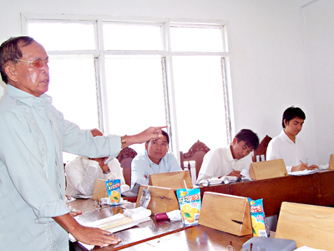

An SB Member asking how the DENR can help the municipality of San Francisco in solving boundary conflicts with their adjacent municipalities.

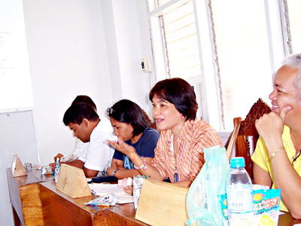

RPAO Chief Purificacion S. Daloos discussing the Terms of Reference and the contents of the MOA for Adopt-a-Mojon Project to the municipal officials in San Francisco.

SAN RICARDO, Southern Leyte

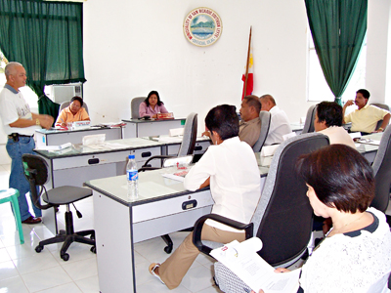

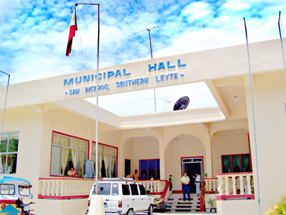

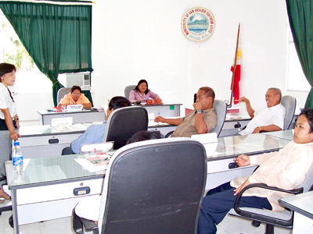
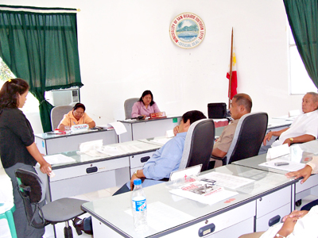

Top: FNSP Chief Engr. Eraklio Ray Bañez Jr. giving an orientation on the PRS ’92 Program to the SB members of San Ricardo.

Bottom Left: RPAO Chief, Purificacion S. Daloos explaining the contents of the MOA on Adopt-a-Mojon Program.

Bottom Right: LMS Mathematician Maricor Maestre explaining the contents of the pre-formatted municipal ordinance to be enactd by the SB for the protection and conservation of the geodetic control points.

PINTUYAN, Southern Leyte

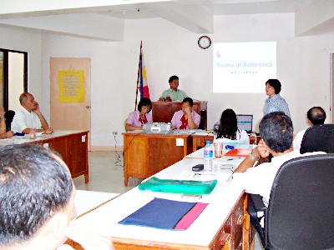

RPAO’s Purificacion S. Daloos explaining the purpose of the Focused Group Discussion with the SB members of Pintuyan.

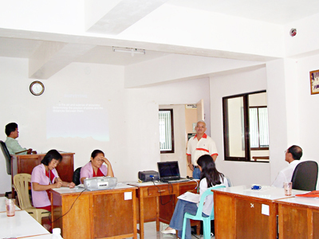

FNSP’s Engr. Bañez expounding the background of the PRS ’92 Program and the role of the LGUs in the protection and conservation of the GCPs.

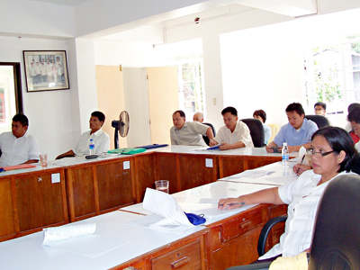

SB members of Pintuyan intently listening during the discussion.

